***Music genre classification Project Report:***

**1. Introduction**

Music genre classification is a fundamental task in audio processing with wide-ranging applications including recommendation systems, music retrieval, and personalized playlists. As the volume of digital music continues to grow exponentially, automated methods for genre classification have become increasingly crucial. This report explores the utilization of deep learning techniques, specifically convolutional neural networks (CNNs) and transfer learning, coupled with the user-friendly interface of Streamlit to develop a robust and efficient music genre classification system. The report provides insights into the methodology, implementation details, results, and future directions of the project.

**2. Methodology**

**2.1 Data Acquisition and Preprocessing**

The dataset utilized in this project is the GTZAN dataset, a widely used benchmark dataset for music genre classification. It consists of 1000 audio excerpts, each 30 seconds long, spanning ten different genres. Audio files are preprocessed to extract spectrograms, which serve as input features for the deep learning model.

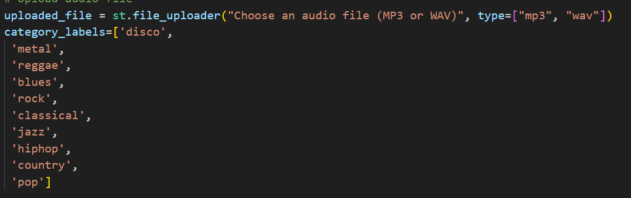

**2.2 Model Architecture**

The core of the classification system is a convolutional neural network (CNN), specifically ResNet-50, pre-trained on the ImageNet dataset. The pre-trained ResNet-50 is utilized as a feature extractor, with additional layers added for genre classification. Transfer learning is employed to leverage the learned features of ResNet-50 for the music genre classification task.

**2.3 Streamlit Integration**

Streamlit, a powerful Python library for creating interactive web applications, is utilized to develop a user-friendly interface for the genre classification system. Users can upload audio files in MP3 or WAV format, and the system provides real-time genre predictions.

**3. Implementation Details**

The implementation is divided into two main components: model training and Streamlit app development.

**3.1 Model Training**

The training pipeline involves loading the dataset, extracting spectrogram features from audio files, splitting the data into training, validation, and test sets, and fine-tuning the pre-trained ResNet-50 model. The model is trained using the Adam optimizer and sparse categorical cross-entropy loss function.

**Accuracy of model**

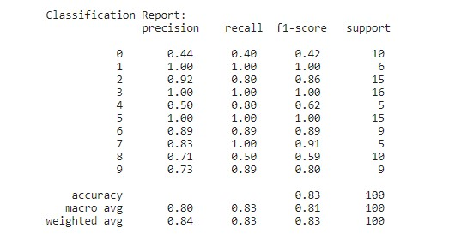

**Heat Map**

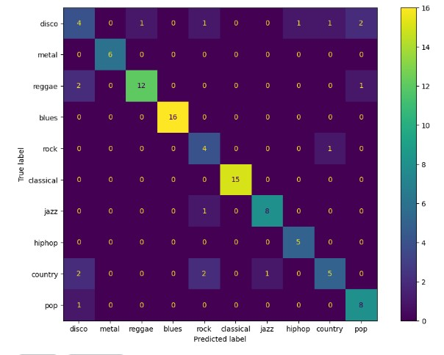

**Plot**

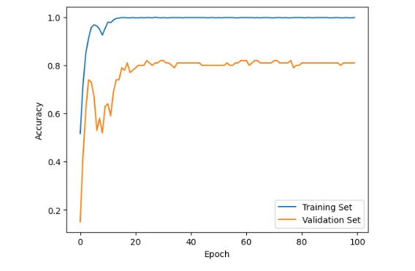

**3.2 Streamlit App Development**

The Streamlit app provides a user-friendly interface for genre classification. Users can upload audio files, and the app utilizes the trained model to predict the genre in real-time.

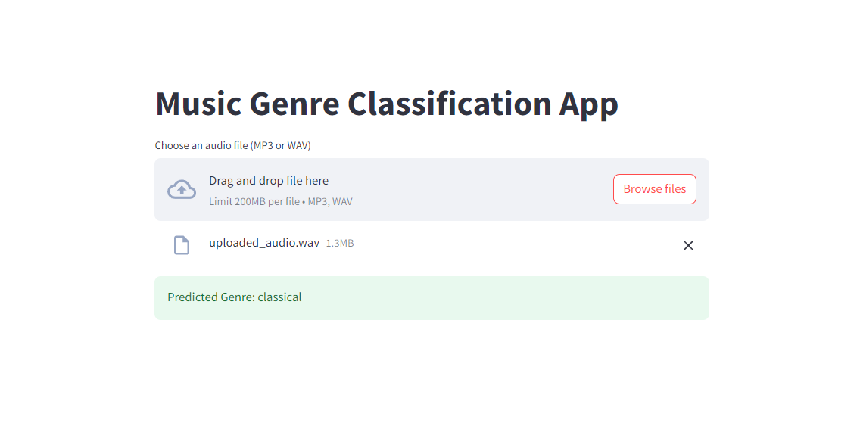

Interface of Deep learning project using streamlit.